Ideation Phase
Empathize & Discover
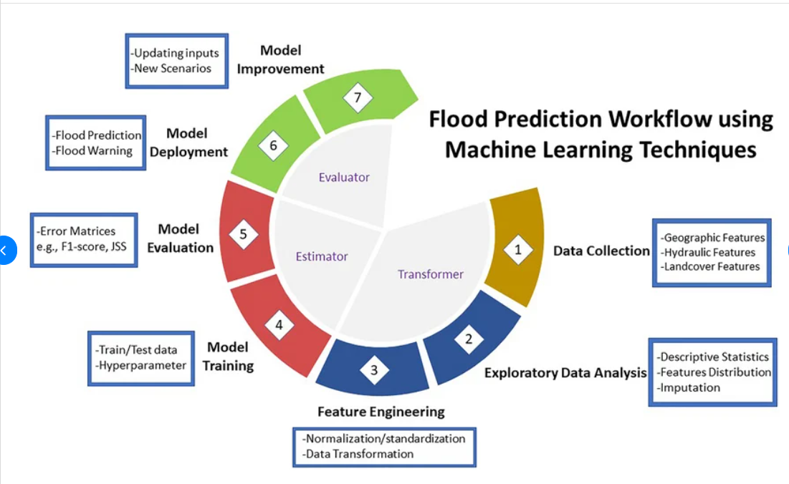
Flood Prediction System Workflow
The Flood Prediction System follows a structured workflow to provide accurate flood risk predictions. First, historical and real-time weather data such as annual rainfall, cloud visibility, and seasonal rainfall are collected as input. The data is then preprocessed by handling missing values, encoding categorical variables, and normalizing features where required.
The processed dataset is used to train multiple machine learning models, including Decision Tree, Random Forest, K-Nearest Neighbours (KNN), and XGBoost. Each model is evaluated using performance metrics such as accuracy, precision, recall, and F1-score. The best-performing model is selected and saved.
The trained model is integrated into a Flask web application. Users enter current weather parameters through the web interface, and the application sends the input to the trained model. The model predicts whether there is a high or low risk of flooding and displays the result instantly. This enables authorities and disaster management teams to make informed decisions regarding early warnings, evacuation planning, and resource allocation.

